**Project Euler #173: Using up to one million tiles how many different "hollow" square laminae can be formed?**

We shall define a square lamina to be a square outline with a square "hole" so that the shape possesses vertical and horizontal symmetry. For example, using exactly thirty-two square tiles we can form two different square laminae:

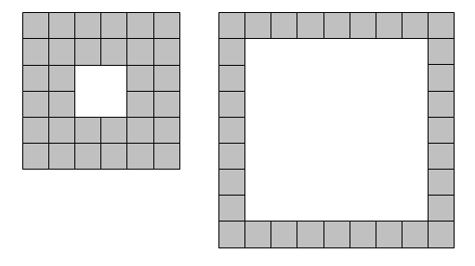

With one-hundred tiles, and not necessarily using all of the tiles at one time, it is possible to form forty-one different square laminae.

Using up to *n* tiles how many different square laminae can be formed?

**Input Format**

The only integer *n* is given on the first line.

**Constraints**

* 1 <= *n* <= 10^12

**Output Format**

Print the only integer which is the number of such square laminae.

**Sample Input 0**

100

**Sample Output 0**

41

**Explanation 0**

As written in the statement, for 100 tiles there are only 41 different laminaes.